WOMS 230 / NIU / Action Research Project

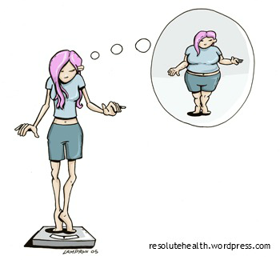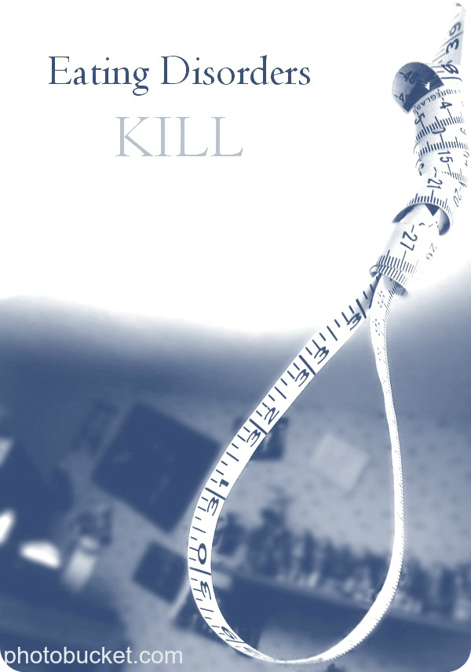

Eating disorders:

* cause more deaths than any other mental illness
* lead to medical issues (such as an irregular heartbeat or infertility)
* lead to suicide, depression, or severe anxiety
* cause distress to family and friends of the patient

Eating disorders can affect anyone you know, and they cause mental distress, medical problems, and death.

# Why Should You Care?

Want more information on this topic?

Visit: eatingdisorderscoalition.org

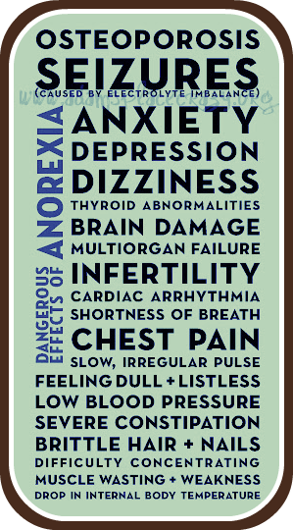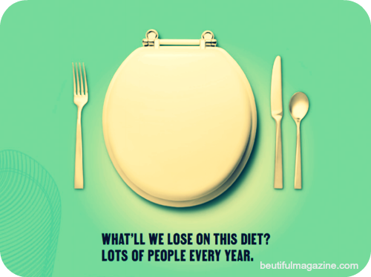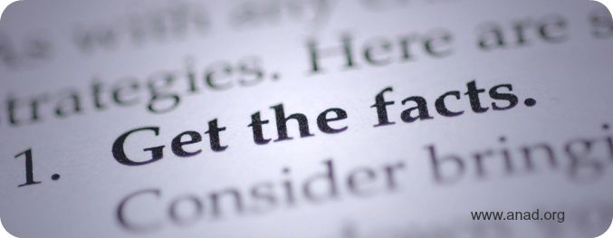

#### *Un*Fun Facts

#### *Un*Fun Facts

* “Between 5-20% of individuals struggling with anorexia nervosa will die.”
* “People struggling with bulimia nervosa usually appear to be of average body weight.”
* “People with binge eating disorder report a lower quality of life than non-binge eating disorder.”

-Nationaleatingdisorders.org

**Anorexia Nervousa**

Characterized By: Self-starvation and excessive

weight loss

Health Consequences

* Severe dehydration
* Fainting and fatigue
* Abnormally slow heart rate and low blood pressure

**Bulimia Nervousa**

Characterized By: binge eating compensated for with

behaviors such as self-induced

vomiting or laxative abuse

Health Consequences:

* inflammation and possible rupture of the esophagus (from vomiting)
* tooth decay and staining (from vomiting)
* chronic irregular bowel movement and constipation (from laxative abuse)

**Binge Eating Disorder**

Characterized By: binge eating without regularly

compensating for the consummation of

unusually large amounts of food

Health Consequences:

* high blood pressure and cholesterol
* heart disease
* gallbladder disease
* “Risk of death from suicide or medical complications is markedly increased for eating disorders”
* “Anorexia nervosa is one of the most common psychiatric diagnoses in young women.”
* “Estimates indicate that about 60% of people struggling with binge eating disorder are female, 40% are male”

*-Nationaleatingdisorders.org*



Want more information on this topic?

Visit: nationaleatingdisorders.org

#### Types of Eating Disorders

